

Matthew J. Leaper

1903216

Enhancing Web Translation by Utilising Artificial Intelligence and Natural Language Processing

Bsc. Computer Science

Undergraduate Thesis Report

Department of Computer Science, University of Bedfordshire

Supervisor: Dr Vitaly Schetinin

Academic Year: 2023/2024

Abstract

This report will delve into the essential requirements for developing an enhancing an Artificial Intelligence based web translator, it will explore existing versions of this concept as well as examine the relevant and recent literature and research on this field. Once the model is developed, this report will outline the methods and practices for implementing and integration into a website, as well as methods and insight into enhancing the overall user experience and visual appeal. After this, this report will provide insight into the testing and evaluation of the artefact, further testing the requirements of what is needed for a successful AI-based translator.

Acknowledgements

I would like to thank the University of Bedfordshire for its support and education given to ensure that this report has been completed, I would also like to extend my gratitude towards my supervisor Dr Vitaly Schetinin for supporting and believing in me through every step of this process.

As well as a special thank you to my family and friends who have always been with me and supported me through my journey in this life, I would have never made it this far without all of you, thank you.

Dedication

I dedicate this work to Sasha, Susan and Sandra.

Contents Page:

Title Page…………………………………………………………………………………1

Contents…………………………………………………………………………………. 3

Chapter 1 Introduction………………………………………………….….…………….4

Chapter 2 Research ………………………………………………………………………5

Similar Products……………………………………………………………….…9

Text to Text Transfer Transformers…………………………………………….12

Chapter 3 Design………………………………………………………………………..12

Chapter 4 Implementation………………………………………………………………15

Flask and HTML…………………………………………………….………….15

T5……………………………………………………………………………….19

Tokenization…………………………………………………………………….20

Fine Tuning……………………………………………………………………..22

Inference………………………………………………………………………...27

Working Website Model………………………………………………………..30

CSS……………………………………………………………………………...37

Chapter 5 Testing……………………………………………………………………….50

HTML testing…………………………………………………………………...50

Base translation testing………………………………………………………….51

Feature testing…………………………………………………………………..52

CSS testing….…………………………………………………………………..52

Final testing……………………………………………………………..………54

Chapter 6 Conclusion…………………………………………………………………...56

References………………………………………………………………………………59

Appendices………………...……………………………………………………………62

Introduction

In the current era of the world, with rapid increase in population and civilization, the importance of strong communication has never been more pressing. With the advancements of the internet, companies and individuals have been utilising the power of internet-based translators to bridge communication gaps between people. However, there are issues and challenges that can arise with the already existing translators, this can lead to misunderstandings and language barriers between people. The University of Bedfordshire has a significant number of international students, who have at times found issues with communicating with other students as well as lecturers.

To address these issues, the power of Artificial Intelligence (AI) and Natural Language Processing (NLP) has become a staple in web-based and application translators, with the use of advanced algorithms alongside machine learning (ML) techniques, AI-powered translators have the ability and potential to increase the accuracy of translations as well as adapt the how languages change and evolve.

This thesis will delve into the uses, development and integration of AI-powered translators, looking into pre-existing literature on the subject as well as explore how a model will be created in depth and integrated into a website. This thesis will shed a light on the world of AI and NLP and its uses in improving interpersonal communication.

Furthermore, this report will look into the challenges and limitations of AI and NLP in web translation addressing issues such as similarities between languages, spelling issues and difficulties with context and basic communications, ultimately though this thesis will look into the potential of artificial intelligence and its ability in making the world more accessible for everyone allowing more exchange in culture as well as ensure a more interconnected world.

Requirements

This section of this thesis will look into the requirements of the artefact being developed, one of the main requirements being that the product must be accessible for everyone, the table below gives a brief insight into the requirements for this project to succeed, how important the requirements are and how they could and would be done.

|  |  |  |
| --- | --- | --- |
| Requirement | Relevance (MoSCoW) | How? |
| Model translates | Must | Use of a text-to-text transfer transformer model which has been fine tuned |
| Detect the Language | Should | Python module which allows for 55 languages to be detected |
| Define words | Could | Python module which gives accurate definitions of words |
| Utilise microphone on devices | Could | HTML code which reverts back to python for transfer. |
| Implement into Website | Must | Use of Flask, a python addon. |
| Make accessible for mobile site | Could | Use of HTML and CSS to make it available for website |
| Use CSS to ensure website is attractive for users | Could | The programming language CSS (cascading style sheets) allows for HTML to be customised and made more attractive for users |

Figure 1, Table of Requirements

Research

The world of AI and NLP are already vast, and with rapid advances in technology they are becoming more so by the day. Large language models are currently a massive part of technology in 2024 with the appearance and power of sites such as ChatGPT, LLMs are taking over the world of technology. This section will look into the existing products and resources in the world of NLP as well as online translators, how they work, function and their effectiveness.

This next section will look into the recent reports and developments within the world of AI and NLP, it will look into research papers, books and existing models available to the public.

# Progress in Neural NLP: Modelling, Learning, and Reasoning (Zhou, M. *et al.* 2020)

This article looks into the recent developments in NLP from years 2015-2020, it covers the modelling, learning and reasoning of the frameworks and how they have developed in recent years to make NLP an important function and practice within the modern world, it talks about how the majority of voice command systems, such as Alexas, and Google Homes, require NLP to function and give helpful and fast responses to the users, as well as search engines with included predicted search features, which suggests why search engines such as google have been constantly improving over the past few years.

Artificial Intelligence (Boden, 1996)

This book offers a great insight of AI, covering fundamental concepts, ethical issues and problems, and the historical background of the field. The primary focus on this book will be on the 8th chapter of the book, dedicated to Natural Language Processing (NLP), a crucial element for this project. This chapter extensively looks into the background and mathematical foundations of NLP, including grammar theories, specific word analyses, and sentence structures, this book gives a deeper understanding of how NLP functions within the framework of artificial intelligence.

Fundamentals of artificial intelligence (Choudhary, 2020)

This book was a ground-breaking insight into the world of AI, as recommended by most universities for students delving into the artificial intelligence world, it highlights great information towards the concepts, ethics and mathematics behind the ever-changing field of study. It highlights great and interesting points on AI as well as NLP, giving the reading a greater perception of the ideas and knowledge needed to make any AI product successful, similarly to the first book I will be attempting to use both of these in the development of my artefact and my final report, as I believe they give all information behind the theory and the historical background of artificial intelligence.

How can NLP-based Language Translation solve Real-World Problems? (2023)

This article offers great insight on this topic, as it highlights the use of NLP in the form of a translator, gives a brief insight into the history of translation in NLP and highlights all of the additional information that would be useful to carry out such a task, it also highlights the idea that NLP could make great advancements within the medical business world.

Human Language Technologies as a Challenge for Computer Science and Linguistics (Vetulani, Z, *et al*. 2023)

Written by Zygmunt Vetulani & Patrick Paroubek, this book is fantastic for understanding the theory of mathematics and the linguistics within NLP, as In Immanuel Kant's words, “Experience without theory is blind, but theory without experience is mere intellectual play” (The Thomas B. Fordham Institute, 2015). The combination of these books and articles will help create and maintain a deeper grasp on the world of artificial intelligence and natural language processing, allowing a viable option to create and develop a working artefact which can accurately detect and translate words, phrases and sentences. The book was released this year and massively highlights the progression of using NLP for different functions and projects.

Summary

In summary, the previous articles and books found show great developments and progression within the ever-expanding world of AI. They provide vital building blocks for any form of NLP development, starting from introduction they describe the fundamentals and basics of the complex field after which they then increase into an in-depth analysis of the world of AI.

This next section of the literature review will look at the already existing models available to the public for use.

DeepL Translate:

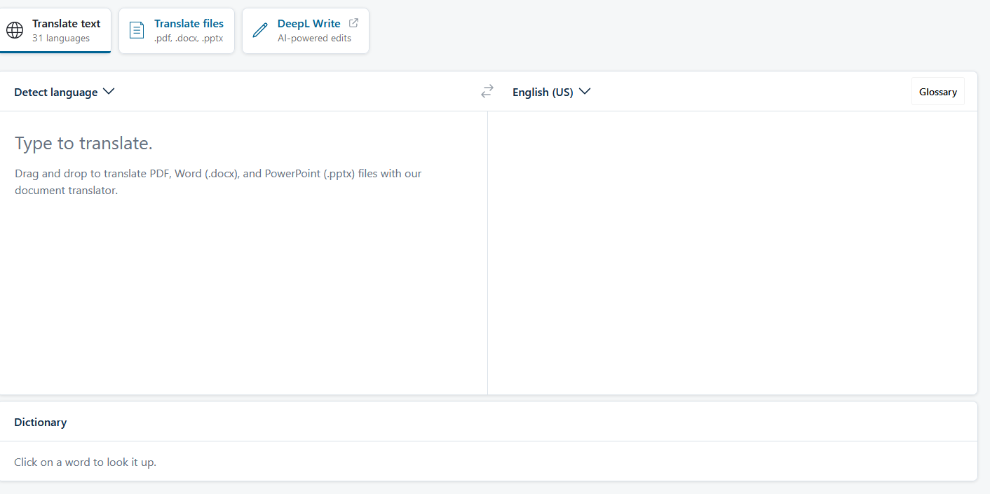

Figure 2, DeepL Translate (2024).

DeepL translate is a web-based translation tool available on the market, it claims a staggering 100% accuracy on all of its translations, the only web-translator to boast this, DeepL (2019). DeepL has a clean user interface allowing for pleasurable user interactions as well as additional features such as an inbuilt dictionary for definitions of words. To enable higher user feedback, it offers a response section for all of the issues found within the website allowing for a completer and more user-friendly feel.

However, there are issues with DeepL, the main issue is pricing, whilst having a free option available to users, DeepL’s ‘Ultimate’ membership costs a staggering $49.99 per month, this averages at around $600 per annum, the main difference between its versions is the lack of security within its free membership option, meaning that all data inputted into DeepL is stored which can cause sever concerns regarding data privacy for customers. Another issue with DeepL is its lack of language options, having only a limited number of languages for the user promotes higher rates of accuracy between languages, however combined with a monthly subscription raises moral and ethical concerns.

The Cambridge Dictionary Translator:

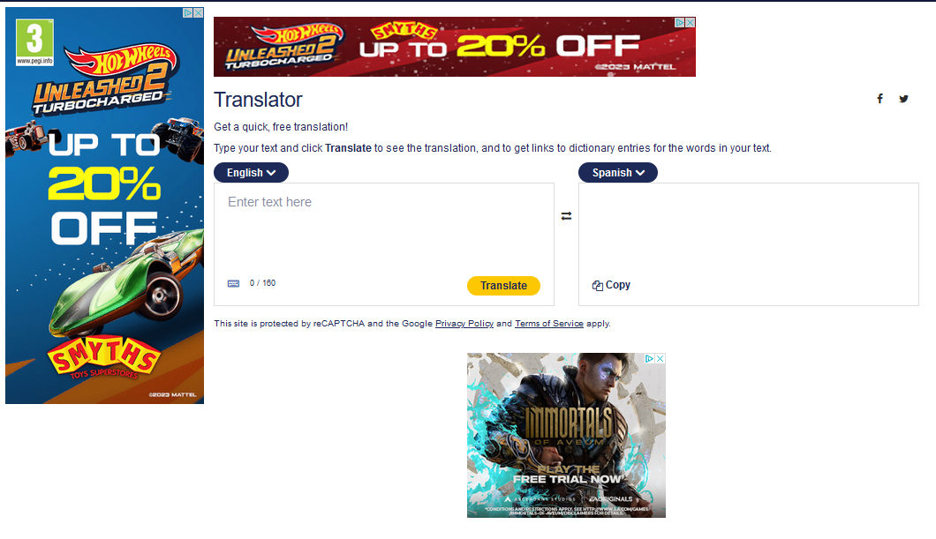

Figure 3, Cambridge Dictionary Translator (2024).

The Cambridge Dictionary Translator is another example of an already existing product, the model offers free translations between multiple languages however that is where the benefits of this model finish, the website as a whole is littered with unappealing advertisements, this in turn makes the viewing pleasure as well as the user experience disappointing, the website offers a small amount of character numbers for translations and similar to DeepL the Cambridge Dictionary Translator has security concerns as it also stores user’s data, this alongside the irrelevant advertisements make the website as a whole feel untrustworthy despite being from such prominent background as the Cambridge Dictionary.

Google Translate:

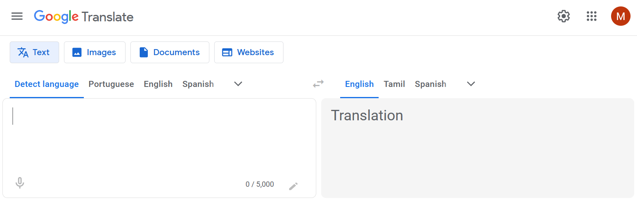

Figure 4, Google Translate (2024).

In the world of online translation and NLP, the powerhouse Google cannot go unmentioned. Google Translate has been dominating the translation world since its launch in 2006 and since then has only increased in capability and power, with the vast improvements in AI and LLMs Google Translate has become a staple in the majority of people's lives and helped many around the world. (Pitman, 2021)

The Google Translate model uses an NMT, a neural machine translation model. Developed and introduced in 2016 the Google Neural Machine Translation model, GNMT, was designed to massively increase the accuracy of their Google Translate product, the model consists of an encoder and decoder and the ability for over 160 million parameters, offering a decrease in 60% in errors in comparison to their original version, they believe that the NMT models have “the potential to overcome many of the weaknesses of conventional phrase-based translation systems.” (Google, 2016). Unfortunately for this project however the GNMT model is far too large for this system in use therefore an alternative model needs to be identified.

Google Translate is the current industry standard, because of this it has to account to more than just the accuracy of their model, the website as a whole is clean and appealing, it fits their branding throughout their products as well as has good implementation to search results and images as well as mobile devices for example the inbuilt keyboard on android devices.

Due to the size of the GNMT, the Text to Text Transfer Transformer model, T5 Model, is almost ideal, originally proposed in 2019 by developers at Google, the model is pre-trained on a series of supervised and unsupervised multitask tasks, this includes translation, question answering and summarising, then the model is finetuned down to a specific purpose, this allows for the base model to be released with multiple functionalities making it a powerful model for most NLP tasks.

The T5 model works similarly to the GNMT model as it has an encoder-decoder architecture, however it is significantly smaller on request, due to the different sizes available, the T5-small model, also originally developed by google, is ideal for this project as it gives enough computing power whilst also being small enough to run on the system being used.

Design

This section will focus on the design aspects of this project, this will include the planning behind the project as well as the components used and explore pre-implementation feature planning.

The design phase began with creating multiple working sections of the project, then injecting and implementing them together towards the end. The reason for this was it allowed for constant testing of the working parts and ensured that if any issues were to occur the problems could be diagnosed easily and efficiently. To begin the project was set out to be implemented into a website, therefore a Unified Modelling Language diagram (UML) was created to display and show the processes of the website as a whole.

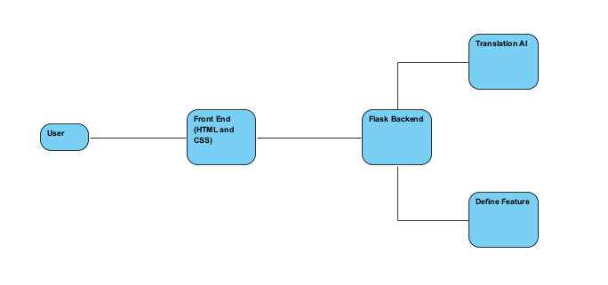

Figure 5, Basic UML Diagram

This basic UML was created to show the website interactions, for example the user would only ever interact with the frontend of the website and the frontend would only interact with the user and the backend.

This diagram was used to illustrate the overarching map of the project's main elements and their interconnectivity, it also helps to plan and separate different parts together, utilising high cohesion and low coupling, the different parts of the website could be linked and separated depending on their function. In this case the parts of the frontend and backend would be completely independent and would communicate through functions and requests, whilst the definition and translation features could be coupled as they both serve specific functions within the site as a whole.

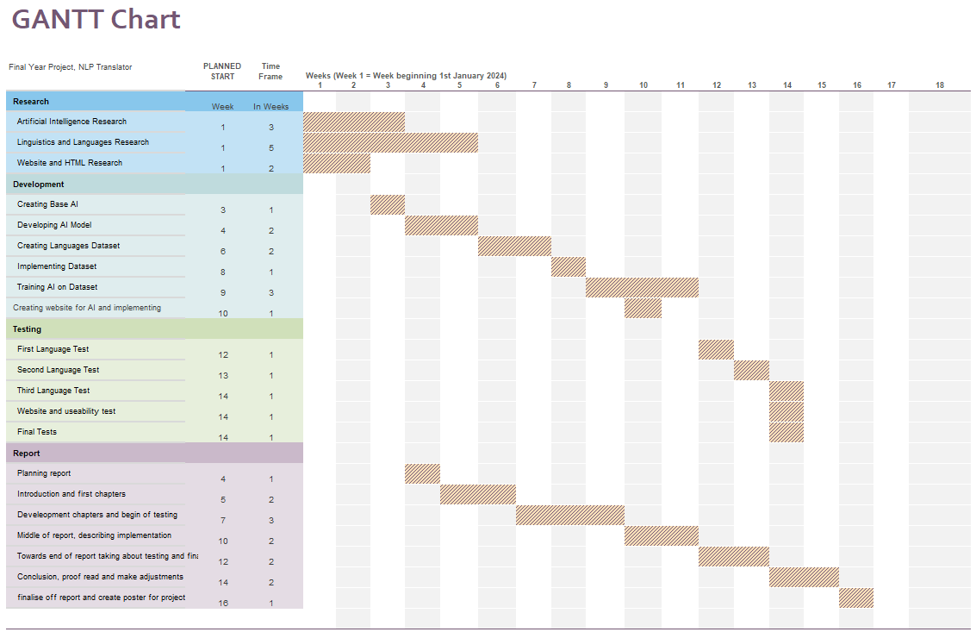

Figure 6, GANTT chart of timeline of project.

Using the GANTT chart created before the project started significantly benefited within the design process of this project, having a mapped-out journey of this project to go alongside the progress helped massively in keeping on track with the design and development stages.

The next step in the design stages was to focus on the main features of the website and how they would interact with the frontend, by designing them to be called by two separate buttons it allowed for a more in-depth UML diagram to carefully describe the process of each button.

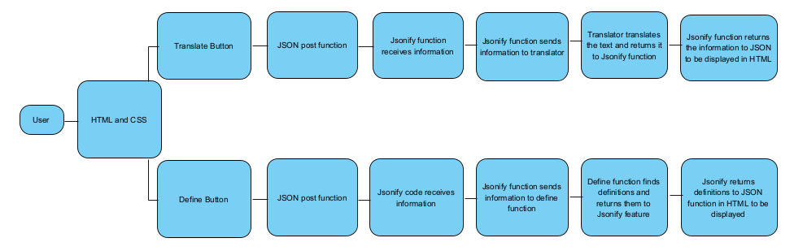

Figure 7, Advanced UML Diagram

The figure shows a direct pathway for the translate and define buttons, both buttons will get sent through JSON and Jsonify to their pre-defined functions within the backend program, once a result is yielded, they both return through the Jsonify and JSON route to be displayed within the HTML, this diagram shows the basic route they will take and the background processes behind the button clicks.

NLTK (natural language toolkit), NLTK is the “leading platform for building Python programs to work with human language data” (NLTK, 2023), the program was written in its entirety in Visual Studio Code, a code editor created by Microsoft, this was chosen due to its ability to run and modify several programming languages, this factor alongside its lightweight yet powerful capabilities meant that it was an ideal choice for this project.

Implementation:

Flask

To create a working model website to function alongside the AI model for the translation, a Flask model was chosen. Flask is a micro web framework ideal for creating simple design websites to implement HTML and CSS, the decision to choose Flask was ideal due to it not requiring any additional libraries to run as well as not requiring any form of database layer for which was not required with this project.

To get started using Flask it must first be installed, this was done in this case using the Windows PowerShell Terminal, using the command pip install flask, this should install all necessary files and the actual Flask library as needed allowing for almost instant use in any python IDE. In this case the command is prefixed by “py -m” this is so that the PowerShell knows that it is a python command and that it should be downloaded into the python folder with the rest of the additional modules and libraries.

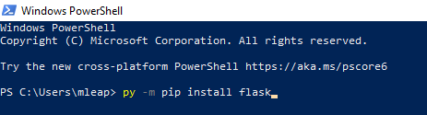

Figure 8, Pip installation of flask.

Once this was completed and Flask was successfully installed, the next step looked at implementation into a program using Visual Studio Code, the lightweight program editor. The process was straightforward as it allowed for multiple Python files to be grouped within one folder, in this case the folder was named Diss. To get started with Flask firstly it needs to be imported along with all additional modules from the framework which will be used, once this was done it was split over two python files, one to control the websites functions and requests as well as another to deal with the connection for the HTML and the CSS, the files in question here are App.py and Views.Py named accordingly for their role, once these programs were created and were run and debugged they created a basic website which no features, a blank canvas with endless possibility for this project.

With the site up and running a HTML file was needed to be the backbone of the website, this included adding in titles and headings, as well as text areas and buttons to allow for ease of use on the site, the HTML file was named Site.HTML and once this was connected into the Flask scripts it was time to begin developing the file more. The initial goal of this was to create a basic functioning website which can then later be developed by adding in the scripts to perform all the functions within the project as well as then add in the CSS to ensure that the site looked professional and higher quality. Headings were added to ensure that HTML file was linked to flask, all necessary features of the website were then added to ensure the requirements were supported, this included a text area for the input and output, along with buttons to initiate the translation and define features as well as drop down bars for language selection, on top of this a few descriptive headings were added so that the premise of the website was clear and forward.

The main aim for these steps was to set up the background elements in preparation for later implementation of the functions as well as the improvement of the aesthetics without running into any additional issues down the line.

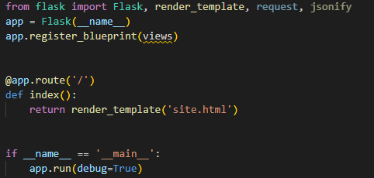

Figure 9, App.Py

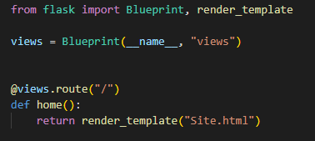

Figure 10, Views.Py

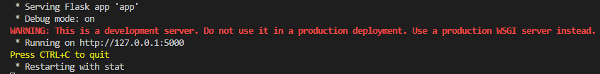

Figure 11, Flask running on localhost.

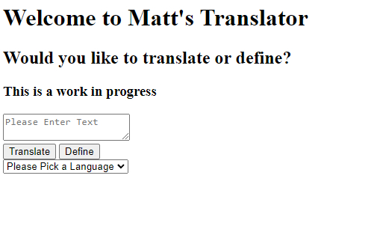

Figure 12, Basic HTML website.

This was the first running version of the website, allowing for me to visualise the design elements and overall feel of the site. At this stage the elements lacked functionality beyond their response to mouse click inputs "drop down etc".

T5 model

With a website running, the next step in this process was to ensure that a working AI model was available, for this reason a T5 model was chosen due to its scalability and its use for many NLP tasks. Written in the Python programming language, the model in use is a PyTorch subclass of its nn module, this allows the model access to PyTorch functionalities like its inbuilt training and inference. The T5 model consists of an encoder to decoder architecture which comes in several different sizes including small, base and large, originally developed by Google it has become a useful model for any form of natural language processing, in this instance a T5-Small model has been chosen due to the smaller requirements of this project, the T5-Small has the capability to utilise 60 million different parameters to help finetune training, making it a smaller version of a large language model (LLM), LLMs are typically trained in two motions, firstly being unsupervised, this occurs by the AI model training itself on unlabelled data to find implicit patterns and matches, followed up with a set of supervised training where the model is trained on a specific dataset which allows it to associate a word or phrase with a corresponding one, this is normally done in the development stage of the model to ensure mass usability.

The T5 model accepts tasks of different variety, by using prefixes within the training and fine-tuning stages, this means that by simple adding a set prefix at the start of the input string, the model can be specifically trained for a certain task, the T5 model framework has built in ability for summarisation, translation, classification, and regression. However, in this project the focus will solely be on the translation tasks available to use.

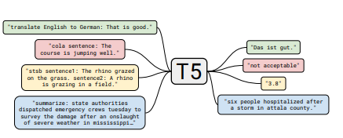

Figure 13, T5 Model Diagram (Raffel et al., 2019)

Tokenization

Tokenization is a crucial part of this process as well as many other machine learning processes too, tokenization refers to the concept of creating a digital representation of a real life thing, in this case the real life entities are words, phrases and characters, for the model to be finetuned on any dataset, it must first convert the datasets into tokens, this occurs when the tokenizer separates the data sets and individually packages each string into a token with a unique serial number, this has to be done so that each entity of the input and output text can be perceived as being an integer so that the model can understand it.

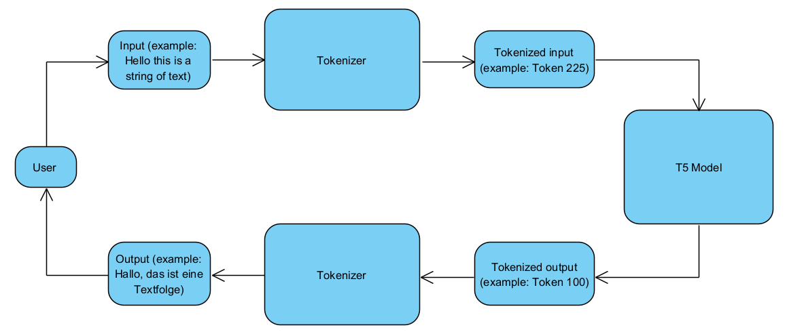

Figure 14, Basic Tokenizer Diagram.

This is an example of how tokenization and T5 model would work together, the user takes an input which is tokenized and sends it to the translator, once translated the tokenizer will detokenize the tokens to reveal the output string for the user.

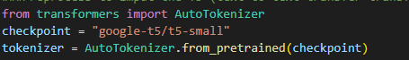

Figure 15, T5 model (huggingface.co, n.d.)

To tokenize the data firstly the tokenizer must be imported into the code, this is done in by using the AutoTokenizer from the transformers module, once this has been done the tokenizer and model must be introduced, by setting the model as the checkpoint and loading that checkpoint into the tokenizer so that associating it with the required model.

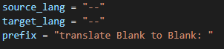

Figure 16, (huggingface.co, n.d.)

After this it is important to define a preprocess function, this will preprocess the data before it is given to the model to finetune, in this example it will take the dataset which will contain a selection of translations from one language to another, once it is decided which language will be the source language and which will be the target language it is important to load the prefix accordingly.

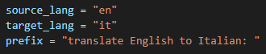

Figure 17, (huggingface.co, n.d.)

In this instance the loaded languages are English as a source and Italian as a target, this is then loaded into the prefix to allow the preprocess function to work correctly.

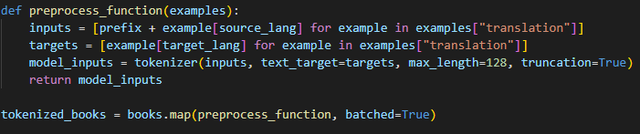

Figure 18, (huggingface.co, n.d.)

The preprocess function is designed to associate the source language with the prefix “Translate English to Italian” as the input into the model, ensuring that the model understands the expectations of the tasks, it also prepares for the target language data to be the expected output of the overall task.

Importantly, upon completion the function must be directed to the dataset, in this case the dataset is defined as ‘books’ it is then called after the definition.



Figure 19, (huggingface.co, n.d.)

This line defines the variable “tokenized_books” as the dataset that has been called through the “preprocess_function”. The line shows that the process is performed in batches in the “batched=True” section, this is for efficiency on the process.

Fine Tuning

Once the model has gone through its stages of training, it can be finetuned for specific use for development. In this case the T5 model was fine-tuned on a number of different datasets to allow for multiple languages learnt, the main datasets in use are from the Opus Books datasets, these are a collection of different books in multiple languages which allow the AI model to learn to match the phrases between the two languages. Once the phrases and lines have been tokenized, in this case there is a target language as well as a source language, the source language is the first version of the book in the dataset which is followed line by line by the target language.

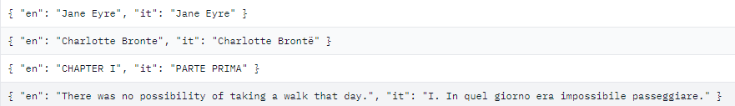

Figure 20, Example dataset, English and Italian (TensorFlow, n.d.) (Brontë, 1847)

Once the dataset has been mapped and pre-processed, it is sent into the model for fine tuning, so that the model can begin to associate the represented tokens with one another allowing for translation, in this instance a sequence to sequence(seq2seq) training model is ideal, a seq2seq is a machine learning technique used for when both the input and output are both sequenced as tokens to improve output fidelity.

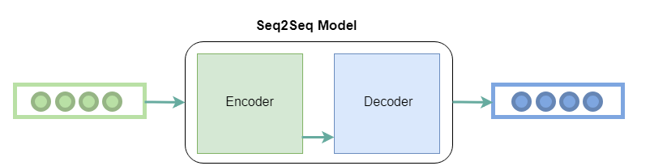

Figure 21, encoder-decoder from (GeeksforGeeks, 2018)

Seq2seq models are composed of an encoder and a decoder. The encoder processes the input sequence and generates a fixed-size context vector that captures the semantic meaning of the input sequence. The decoder then utilises this context vector to generate the output sequence token by token. During training, the model is trained to minimise the difference between the predicted output sequence and the target output sequence. This is typically achieved by employing a loss function (https://www.datacamp.com/tutorial/loss-function-in-machine-learning), such as cross-entropy loss, which measures the disparity between the predicted probability distribution over tokens and the actual distribution.

In seq2seq training, the decoder is often provided with the ground truth tokens, ground truth is the correct answer in machine learning (https://datagen.tech/guides/data-training/ground-truth/#), at each time step, a technique known as teacher forcing. This technique aids in stabilising the training process by offering accurate information to the decoder. Once the decoder generates the predicted sequence, the gradients are computed based on the loss function, and backpropagation is utilised to update the model parameters (both encoder and decoder) in order to minimise the loss.

Seq2Seq training utilises recurrent neural networks, RNNs. RNNs are deep learning models which are specifically trained to process and convert sequential data which has been inputted into specific sequential data as an output, when given the inputs (x) the RNN will generate a series of outputs (y) through an iterative loop based on the following equation.

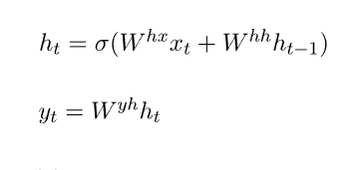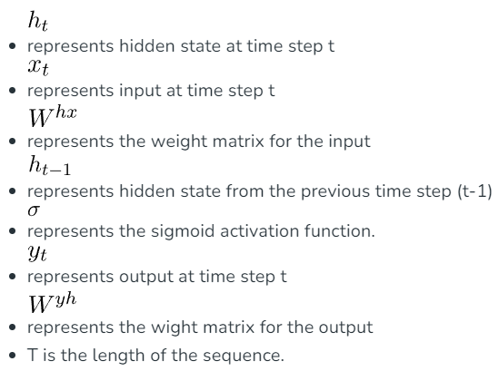

Figure 22, RNN formula (GeeksforGeeks, 2018))

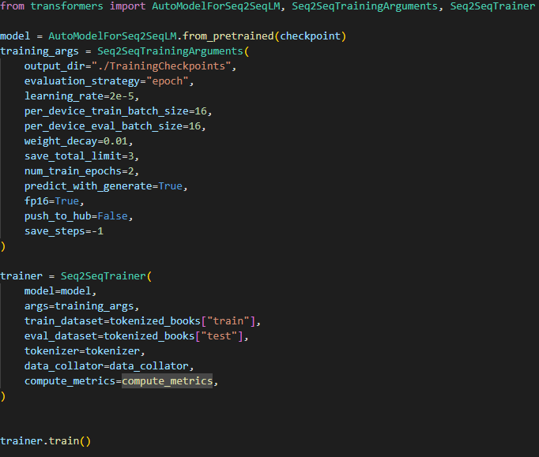

Figure 23, (huggingface.co, n.d.)

In this version of finetuning, the seq2seq trainer is imported from the transformers module, so that the model can be finetuned with the specific parameters required, the model is set from the predefined variable “checkpoint” and the fine-tuned version is sent to the folder “./TrainingCheckpoints”. It is vital to set the “output_dir” to a memorable name, improving accessibility for the user once the training is complete and is required. The parameters defined within the training arguments are a form of presettings for the trainer itself, they are defined as the variable “training_args'' and can be completely changed and set to the users preference, in this regard they have been set so that while training is occurring the model will not create any additional steps for itself, an inherent risk is here as it will not save as it goes along, however it has been done as otherwise it can have major effects on time to train the model causing the project to miss deadlines.

In this instance the models are being fine tuned to a variety of different languages, this is so there is multiple options for the final web based translator, to account for this in the training section it has been set so that the “output_dir” is specific to each language that it learns, for example whilst fine tuning on a Spanish dataset, the “output_dir” was set to “./TrainingCheckpoints/Spanish”. Doing this prevents the model from overtraining on certain languages and confuse the shared words and similarities, this is because the original plan had been to have one model tuned for all languages wanted, however it was discovered that there was issues with multiple languages after the original, this meant there was a working French translator which had been tuned to multiple languages pointlessly, another reason to output the models like this is so that the final website can distinguish between the preferred source and target languages.

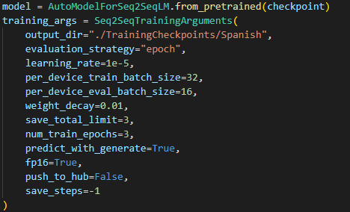

Figure 24, Example Trainer for Spanish (huggingface.co, n.d.)

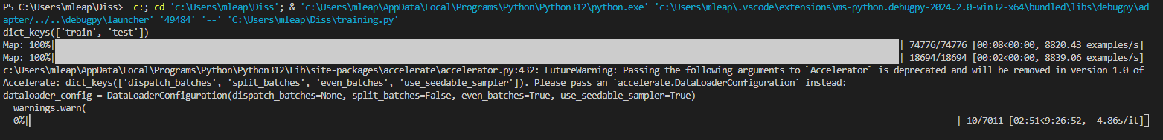

Figure 25, Terminal During Training Process

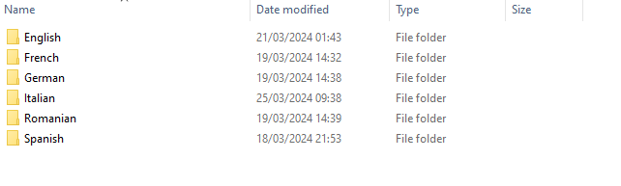

Figure 26, Compilation of Language Models

Inference:

Once the finetuning was complete on the first model, French, it was time to use the model for inference, to do this a replica of a pipeline was written, a pipeline work as an application program interface (API) between the code and the model, only transferring the most relevant and important information between them, to replicate the pipeline. A separate python file was created for the sole purpose of testing the AI models on their ability to translate, this was called AI.py, this code ran as a simple text-based program that would translate through the visual studio console.

Firstly to deal with the prefix issue, whilst fine tuning the model it was important to set a prefix for the tokenizer and dataset so that the T5 model knew which was the source and which was the target language, the prefix ran as a simple string which in regards to the first model was “Translate English to French”, once this prefix was loaded into the text it needed to load the tokenizer, by calling back to the tokenizer within the training.py file it ensured that there would be no issues with incorrect directories, then the tokenizer was loaded with the inputted text, which in this case is user inputted text through the vs code terminal, rather than pre inputted text through the python code itself, once this was done it needed a fine-tuned model to run, this is where individually saving the models came in useful as it allowed for the ability to directly target an individually trained model.

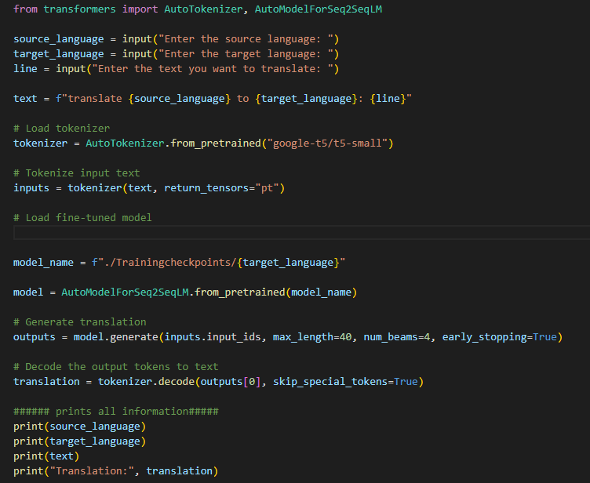

Figure 27, AI.Py program

This is the final version of the inference program, it is designed to take user input for source language, target language and the text to be converted, it will then set the model’s name to the correct folder directory depending on the target language. It is important the when inputting the target_language the user spells the language correctly, this is an issue only in this program, it will then tokenize the text based ready for the T5 model, it will send the text to the T5 model and return it before generating the translation, for added diagnostic purposes a few measures were added into the bottom of the program to display source language, target language, the text and finally the whole string of text including the prefix on the chance off error in within the code.

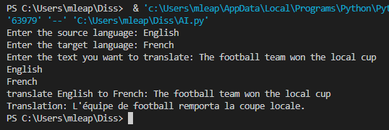

Figure 28, In terminal output of English to French translation.

After initial testing of the inference project, it was clear that the translator, for French, was working somewhat efficiently, there were a few delays in timing to produce results, but these could be reduced by clearing up random access memory (RAM) and ensuring the project was one of the only things running on the computer. Once a base working model was established in one language it was time to train on a series of other languages to broaden the capabilities of the project.

At this stage a few issues were encountered as due to the limited free datasets on the market, alongside the limitations of the computer being used, it meant that many of the language datasets were too small to receive functioning results, on top of this there were issues with timing, as the French dataset had taken over 10 hours to map, download and train, it meant that there were elongated periods of time where the computer was unusable due to most of the RAM and central processing unit (CPU) being used for the program. This meant that the majority of available datasets were either too large for the project as they would consume far too much time and computational power or too small to have any immediate effect, this was the case for Portuguese datasets, as the option for them were either too large for this projects capabilities, or too small to have any actually effect on a model it meant the language was cut from the plan. This process was encountered a lot, and without having to create the necessary datasets by hand it meant that there were only a limited number of languages that could be used freely without licence and continuous strain on the computer. There was a period of time where a GPU solution was looked into to take on the machine learning load, however the GPU in use is not supported for this method, this would have meant that the process of fine tuning the models would have been much faster and the issues with too large datasets would have been less of a problem, that being said each model once fine-tuned takes up more space than a normal python file, therefore fine tuning on large datasets could have caused issues in the long run with uploading and receiving information.

It was then decided that to ensure the most efficient project of this outcome, it would be vital to optimise a limited set of languages with high fidelity rather than a much larger selection with subpar results, this meant that the languages picked would have to have good quality datasets which fit alongside the issues encountered, small enough for the computer yet large enough to make a relevant fine tune, and ensure that all languages included in the final model would be working and of high standard.

Working Website Model

With multiple working parts nearing completion the next stages were to implement them to achieve a working model, to do this the features created on HTML such as buttons and text areas needed to be fixed first, initially the buttons for translate and define were created in the HTML file so that they appeared in the Flask website when loaded up, alongside a text area and some headings to show the current stages of the project, the website was becoming somewhat functional, whilst the buttons did not return any functions yet the text area was able to be used.

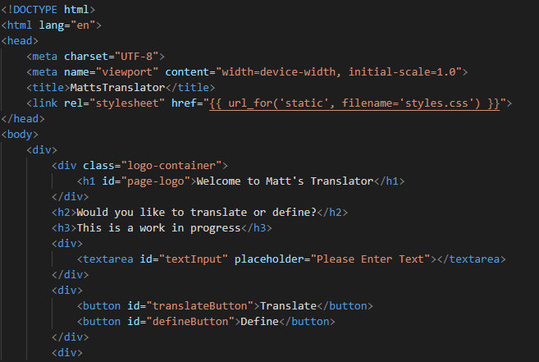

Figure 29, Beginning of HTML program

To incorporate the buttons for the project, they needed to be sent and received by JSON, a lightweight programming language derived from JavaScript. Due to HTML and JavaScript being already compatible it makes JSON ideal as it allows for ease of integration with python script, for the buttons to return python functions they firstly needed to have JSON features to send to the python code, this was done by utilising event listeners, a JavaScript features that looks for certain ‘events’ to occur within a program, such as a button click or text appearing, once the event listeners were introduced for each button, they used a post method to send information, in regards to the define and translate buttons they sent the information from the ‘language’ text area to the python script and they received it and sent it to display within the ‘feedback’ text area. However, for this to work fully, the python script needed to be able to understand the POST methods, to do this firstly Jsonify needed to be included from the Flask module, Jsonify converts arguments into JSON format to be sent and understood by the HTML. To ensure this the jsonify code should be specific towards the buttons in use, for example the translate jsonify function in the python script must be named the same as the translate function JSON function within the HTML, once this is done the python Jsonify script can be sent to a python function to return desired results.

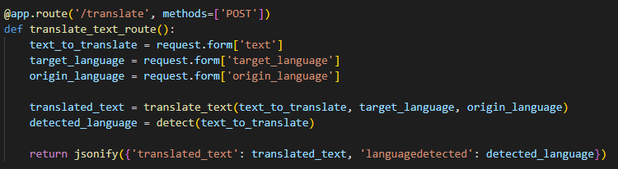

Figure 30, Translate Jsonify Program on App.Py

In this case the python Jsonify script is defining the variable text_to_translate and sending into the translate_text function, once sent into the function it returns the result in Jsonify for the HTML to understand and import into the correct text area.

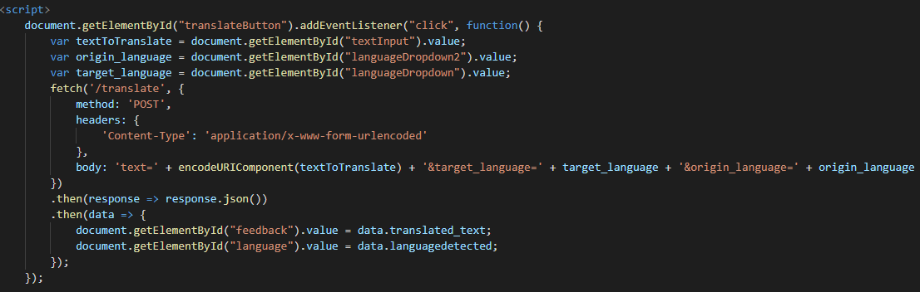

Figure 31, Translate button on HTML for posting function to App.Py.

In summary in this HTML code, the event listener is waiting for a click, specifically on the translateButton, once clicked the function will send the variables textToTransalte, origin_language and target_langauge as a post, once posted the python file will take the variables, send them from the Jsonify function to the translation function, which will translate the text based on the inputted languages, once translated the Jsonify function will take the translated text and return it to the HTML JSON function for it to be displayed in the correct area.

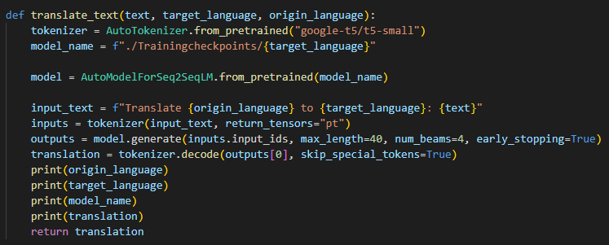

Figure 32, Defined function for translation on App.Py

The function for which the Jsonify segment sends the text to be translated works very similarly to the inference test script, AI.py, it loads the tokenizer and model from the same locations, “Google-T5/T5-Small'' and the file directory where the model is saved. It will then take the information passed from the JSON HTML and use that to input into the model, of which being the text, the origin language as well as the target language, using the same code then as the inference script. The translated string will then be returned to the Jsonify function, as it was that which called it, there were also some ‘print’ features added to ensure that all parts were working properly. One method for this was printing all the given variables to check that they were correct, and the function was using them correctly, as well as the model name and the translation, this information is sent into the terminal for viewing.

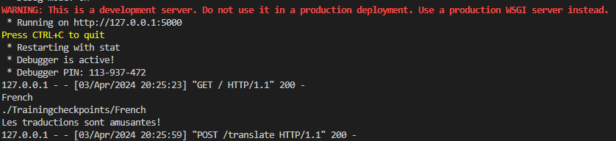

Figure 33, Terminal showing printed outputs for diagnostics.

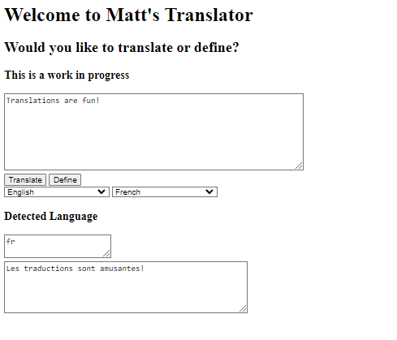

Figure 34, Working French translation.

With the foundation / framework of the program laid work could then begin on developing and enhancing features, therefore the dropdown selections were updated to include all languages present at the time of making, along with updated JSON, Jsonify and python script to make the define button work.

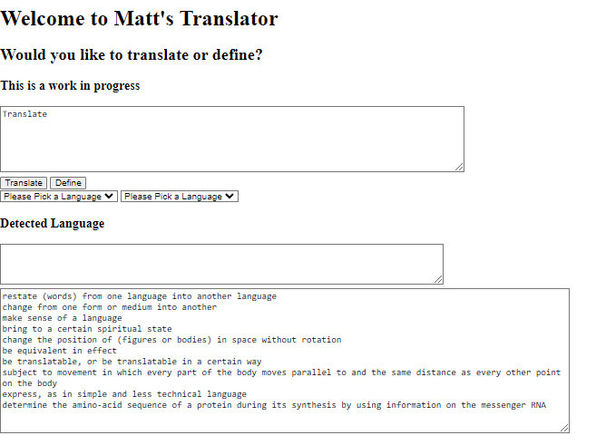

Figure 35, Working definition function.

Once pressed the define button will look for definitions within its library and return the result, similar to the translate feature, it also utilises the POST method on JSON to send and retrieve variables between the two files.

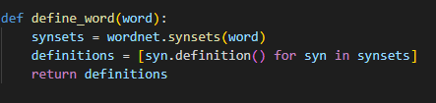

Figure 36, Define word function (NLTK, 2009)

For the button to work, the method of define_word had to be defined, in this case it looks through the built-in library to find a definition for the given word, to utilise this python module it must first be implemented into the code like any other, in this circumstance it uses the natural language toolkit module, NLTK, which comes complete with a working definition add-on.



Figure 37, (NLTK, 2009)

Once imported into the program the features can be used for any function needed, however in this case it will only be used to generate a definition, once the define function is working, it needs to be applied within the Jsonify function to display the information on the webpage.

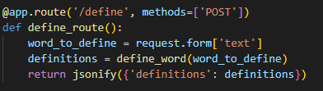

Figure 38, Define word function for posting to HTML.

Code segment outlining the define_route function needed for processing input information.

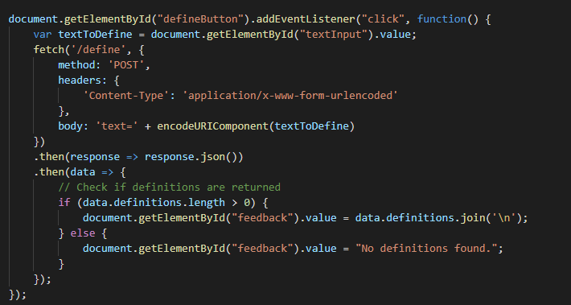

Figure 39, Define word button to send to App.Py

The JSON code within the HTML file then receives the information and then also displays it within the feedback text area like the translation feature. This is because having two text areas seemed at first unnecessary and would have made the final website cluttered with unused addons.

CSS

To improve the aesthetics of the website the programming language CSS, Cascading Style Sheets, was used, this is a vital step as the appearance of a website can massively impact how much a user will trust it, a study stated that 96% of people do not trust certain websites simply for their design (Bpstudios.com, 2017). CSS is a presentation-based language designed to work alongside languages like HTML, CSS allows basic webpages to be enhanced and customised almost entirely, including animation. In order to use CSS firstly a new file needed to be created, ‘styles.css’ was the file created to ensure that the project had an attractive layer, firstly the file needed to be connected to the HTML, placing the CSS page within a folder called ‘static’ meant that the HTML file needed only the URL to access of that folder to ensure that they CSS was connected.



Figure 40, Line of code to link to CSS file

The “stylesheet” referred to the information being found as a CSS file and the href was the reference on how to find it, once this was done it was important to test if they were connected, an viable option to do this would be to observe the terminal within visual studio, once the CSS page was listed within the HTML with a link one of the first things the program will do once refreshed is search for that location.

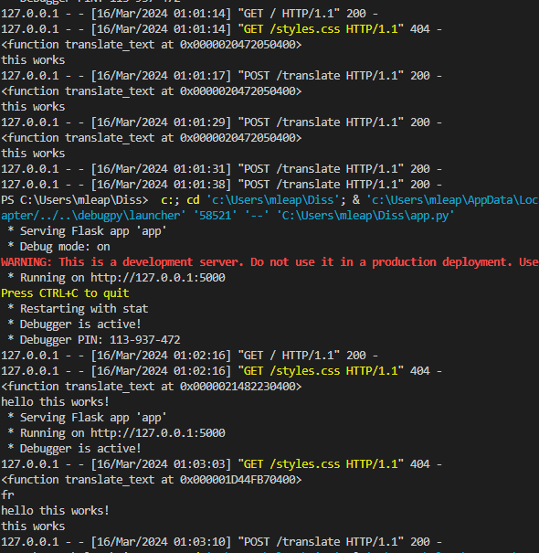

Figure 41, Error 404

Initially there were a few issues with the connecting the HTML and the CSS, despite the CSS folder being in the same folder directory as the HTML and the two being linked within VS code, upon launching the program the only response was an error 404 meaning page not found.

Therefore, the link within HTML needed to be updated to ensure that the program knew exactly where to find the file, hence a slight change to the code was made which meant that the link was more specific.

Figure 42, Updated code for connecting CSS.

When giving the information that the file is within the static folder rather than just the same parent folder, the program returned that the file was now connected through the terminal.



Figure 43, 304 meaning connection to CSS.

Since the connection between HTML and the CSS was working correctly, the next step was to start customising the website. In regard to website viewing consistency between colours, fonts and images is quite important in this regard, a disorganised website is often unappealing and does not strike as a professional product, therefore it was important to find a font and colour scheme which could be enjoyed by most. The colour initially chosen was #becece, a muted blue grey palette which was not distracting to the user thus allowing the user to focus on the function over the visuals.



Figure 44, #becece.

Once the background colour was chosen additions such as font and buttons were changed, font was made into an a ‘Calibri’ like font by preference and the buttons were given rounded edges to make them less sharp, once this was complete the buttons and drop down menus were given a colour gradient background to match the background of the site as a whole, the title and headings were adjusted in font size to show importance as well as all clickable additions were given hover features, this meant that once hovered over with the mouse, the entity would change colour and the mouse type would change.

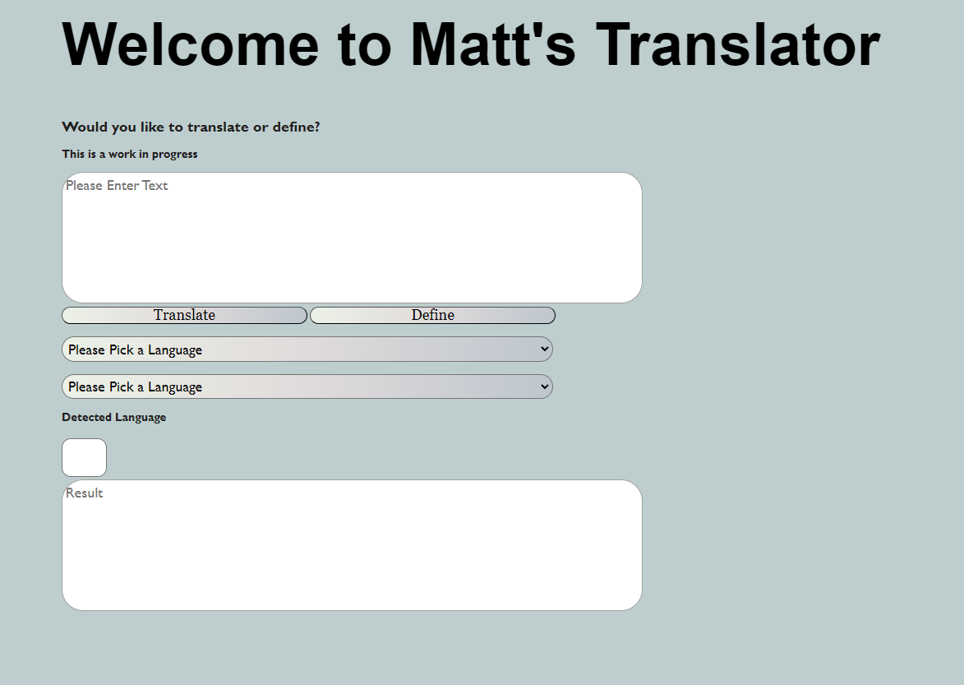

Figure 45, First model of CSS website.

(figure)

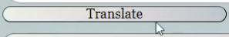

Figure 46, Translate button.

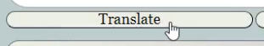

Figure 47, Translate button after being hovered.

This was the first development of the CSS program, in regards to the original HTML it was a significant improvement however there were many changes to be made, firstly the gradients on the buttons and dropdowns were unappealing as they went to dark, as well as the white on the text areas was too striking as a contrast and there was a deep interest in adding some form of animation into the website to make it seem more professional, on top of this whilst enjoying the colour of the background, it felt a bit plain in a general sense, therefore it was planned to update it to make sure it yielded a higher viewing pleasure for the customers.

A simple circular pattern was added to the background of the site to grab more attention than the plain solid colour, this was done so that the website was more visually appealing, it was found that the plain background was far too simple, in addition the background colour was slightly lightened, and the original colour was used for accents in the new gradients on the dropdowns and buttons.

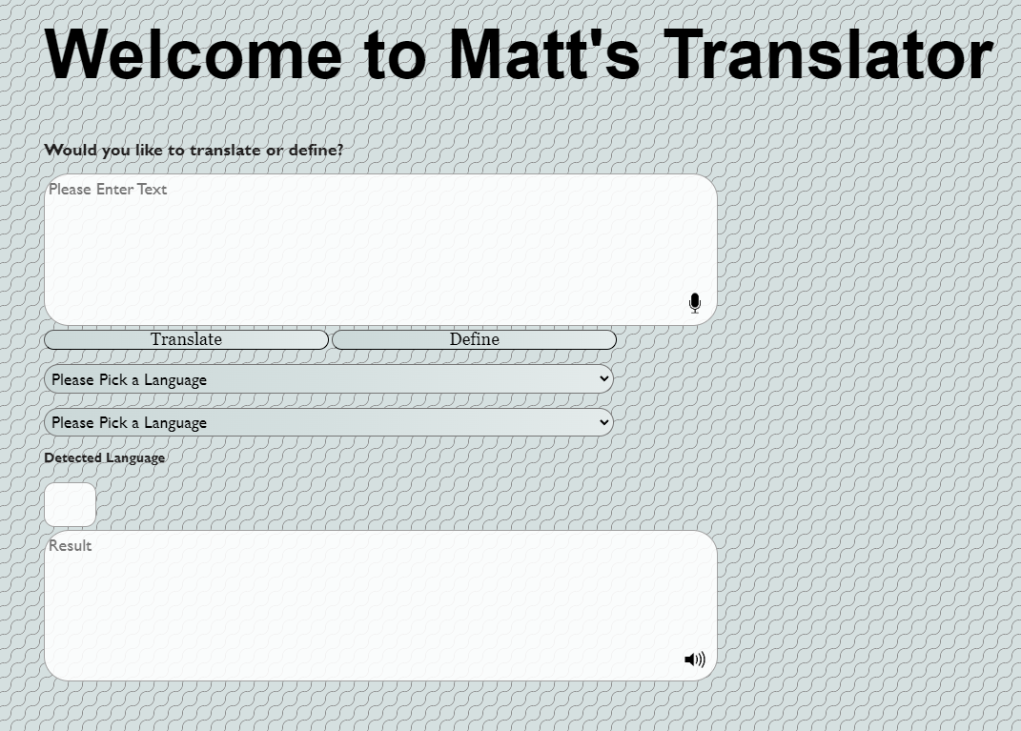

Figure 48, Website after more detailing.

The text areas were also changed slightly by adjusting their opacity, by making them more transparent and slightly darker colour they look less out of place within the website, for additional features on top of this include the ability for text to speech for responses and voice input, both of these are built into the HTML format and are simply there for ease of access for all users, upon using these features however it has been found and stated that the voice on the text to speech was distracting and provided poor pronunciation of certain phrases, the voice being a simple ‘AI generated male voice’ for which sounds very robotic and not at all pleasant.

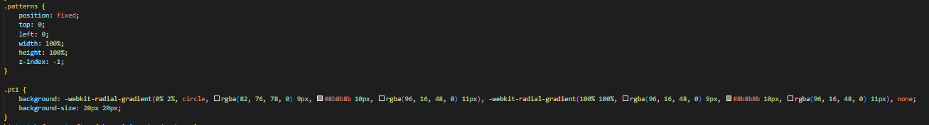

Figure 49, CSS code for background pattern.

The background pattern was built in CSS using a radial gradient, with the colour gradients to identify the colours of the lines as well as the opacity of them.

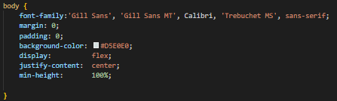

Figure 50, CSS code for main body of website.

A key feature of CSS is inheritance, by setting the font within the body section, all items within this division on the HTML script will inherit the same font meaning that there is no need to repeat the work.

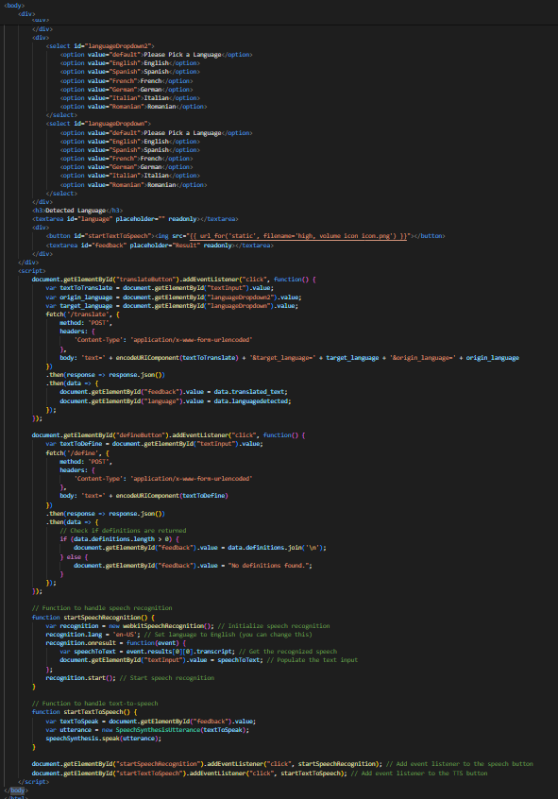

Figure 51, Body of HTML code.

This means that everything within the body class on HTML would inherit all the same attributes, such as the font background colour and its positioning within the site.

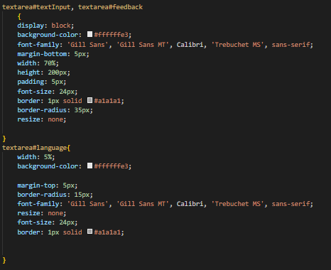

Figure 52, CSS code for text areas.

However when there is a need for certain attributes to have specific properties the features just need to be defined and given parameters within the CSS, if not then they will inherit all attributes that they can, in this case the two text areas for the input and output of the main features, are created so as to share all parameters, such as font size and background colour, however the separate text area which would be to detect the language is left on its own, this is because the ‘language’ text area did not need to share any of the features as the other two, only the shape, in regards to size the goal was the make this box significantly smaller as only little data would be displayed there.

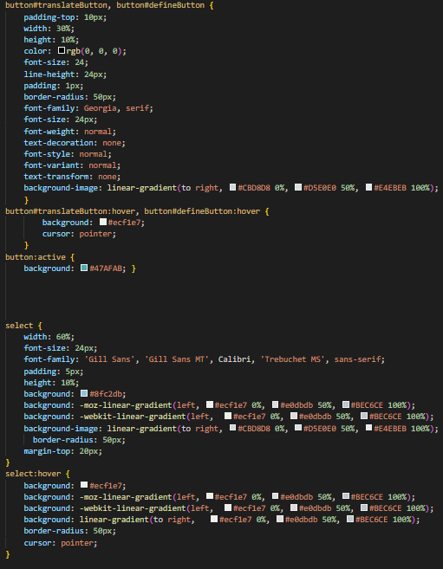

Figure 53, CSS code for buttons and selections.

In this case the CSS script for the two buttons and the dropdown menus are split into only two sections, one for the define and translate buttons and one for the language selections, as the buttons and the selections are planned to be the same within the website the parameters can be set so that both can be adjusted together, the translate and define buttons are not generalised due to there being other buttons within the website which should not share the similar features therefore they are identified with ‘button#translateButton, button#defineButton’, however with their only being two selection dropdowns, they can both fall under the ‘selection’ variable.

The ensure that the project came out looking as professional as possible, there was an element of interest in the idea of adding in an animation for when the website opens, this would be a simple animation such as the main text appearing on the screen for the viewers to see, after some thought and research an animation which had potential had been found, from this site by Embrey (2021) there was an animation which had the starting points to build the ideal animation for this project however there were a few changes to be made, firstly the animation needed to stop after one cycle, on top of that to change the animation path of the line to stop directly over the name ‘MATT’ in the title “WELCOME TO MATT’S TRANSLATOR” and stay there for a second as well as change the colour of the line in so that it complements the background colour and theme of the website.

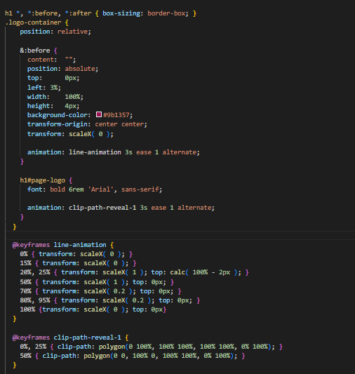

Figure 54, CSS code for animation took inspiration from Embrey (2021)

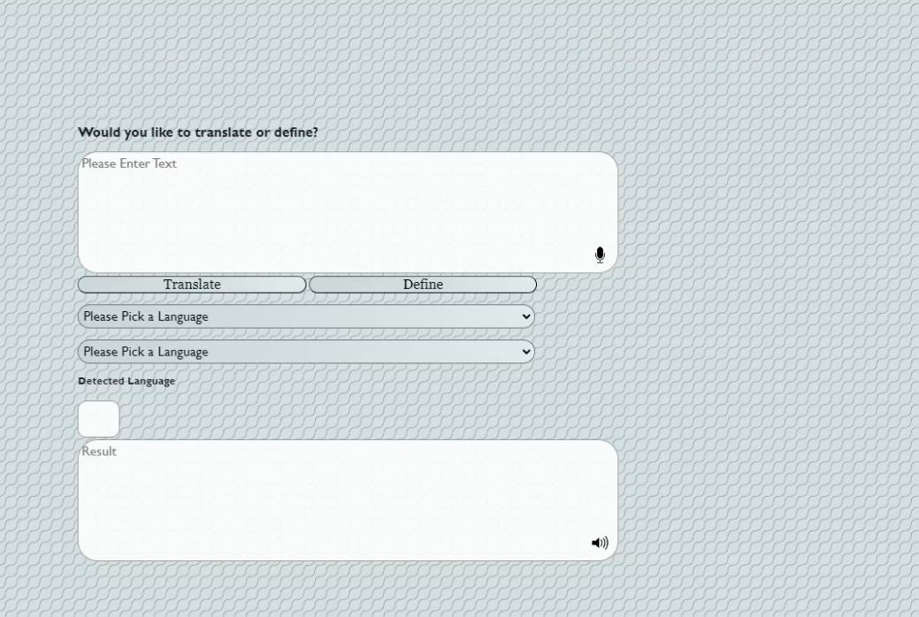

Figure 55, Animation 1/5

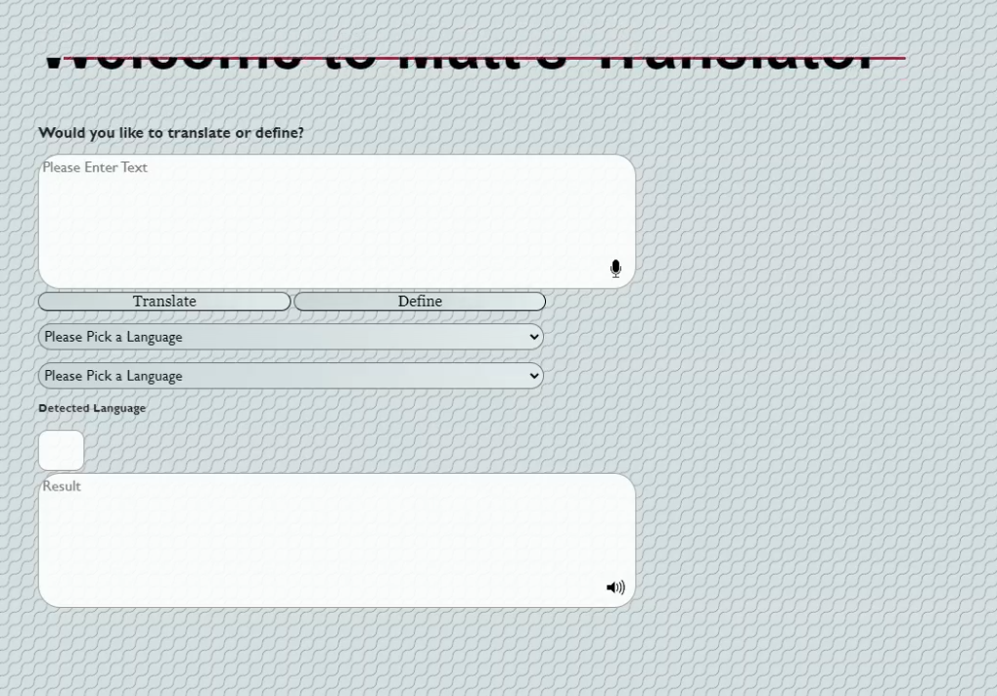

Figure 56, Animation 2/5.

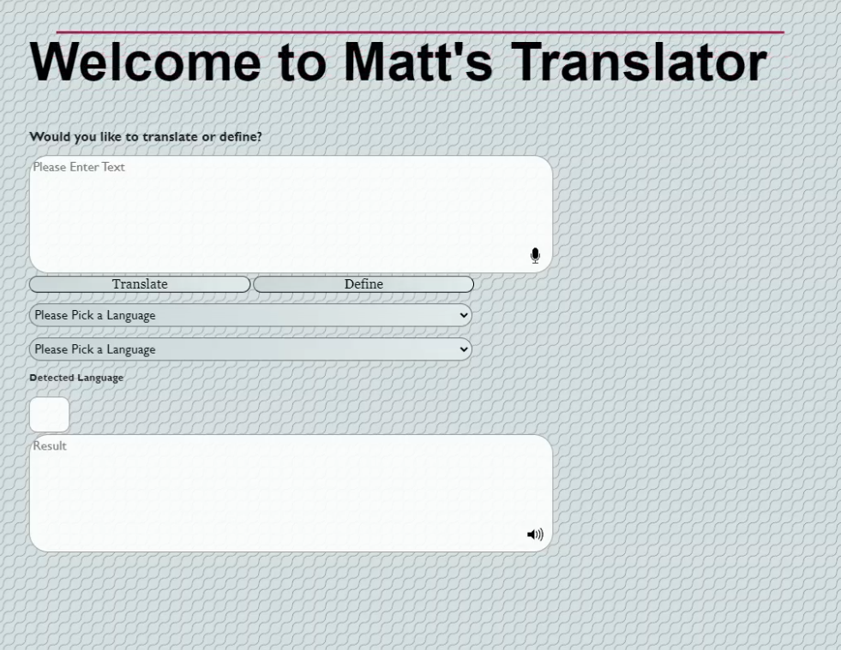

Figure 57, Animation 3/5.

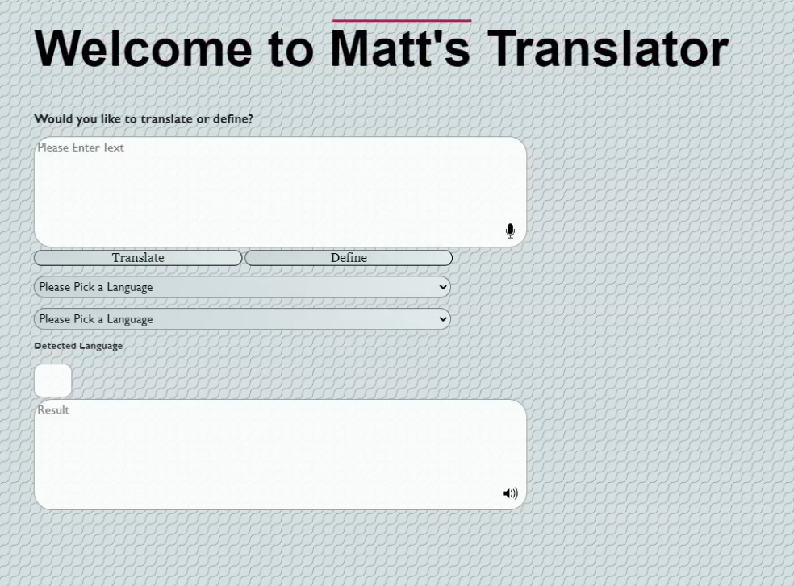

Figure 58, Animation 4/5.

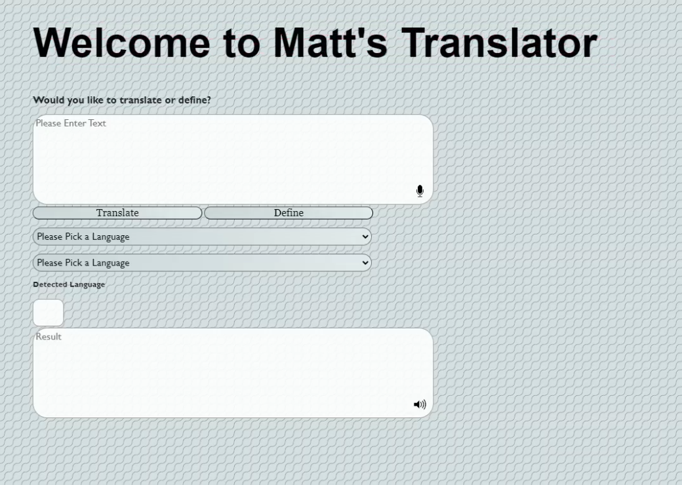

Figure 59, Animation 5/5 / Default website look.

Once the final product was functioning well, it was time to begin the main testing phase, there were elements of testing throughout the whole process.

Testing

To begin with, it was vital to test each step of the process as it went along, this meant that the first tests presented were done for the Flask local host site and final tests were done by participants to test the final project.

|  |  |  |
| --- | --- | --- |
| Flask and HTML testing | | |
| Name of test | Participant / Date | Was the test successful? |
| Flask running on local | Participant 1, 12/02/2024 | Success |
| Implementing HTML code for features | Participant 1, 12/02/2024 | Success |

Figure 60, HTML and Flask testing.

|  |  |  |
| --- | --- | --- |
| T5 Model implementation and usage | | |
| Name of test | Participant / Date | Was the test successful? |
| Implement the T5 model and loading the datasets | Participant 1 / 14/03/2024 | Success |
| Dataset fine tuning on French | Participant 1 / 14/03/2024 | Success |
| Dataset fine tuning on Spanish | Participant 1 / 15/03/2024 | Success |
| Dataset fine tuning on Italian | Participant 1 /16/03/2024 | Fail (dataset too small) |
| Dataset fine tuning on Italian | Participant 1 / 17/03/2024 | Success (Use of different dataset found) |
| Dataset fine tuning on German | Participant 1 / 18/03/2024 | Success |
| Dataset fine tuning on Romanian | Participant 1 / 18/03/2024 | Success (was included in the German dataset) |
| Dataset fine tuning on Portuguese | Participant 1 / 18/03/2024 | Fail (Dataset too small, no ideal dataset to be found) |
| Usability of the inference program | Participant 1 / 19/03/2024 | Success (implemented print codes to check each step) |

Figure 61, Fine tuning testing.

|  |  |  |
| --- | --- | --- |
| Implementation of the Features | | |
| Name of test | Participant / Date | Was the test successful? |
| Adding define feature to define button | Participant 1 / 22/03/2024 | Success |
| Adding in the translation models for the translate button | Participant 1 / 22/03/2024 | Success (However took longer than originally expected) |
| Applying the different models based on the language dropdown | Participant 1 / 22/03/2024 | Success |
| Adding in a detect language feature | Participant 1 / 22/03/2024 | Success |
| Voice input and text to speech output | Participant 1 / 23/03/2024 | Success |

Figure 62, Feature testing.

|  |  |  |
| --- | --- | --- |
| CSS | | |
| Name of test | Participant / Date | Was the test successful? |
| Connecting the HTML and CSS sheets together | Participant 1 / 24/03/2024 | Failure |
| Connecting the HTML and CSS sheets together Test 2 | Participant 1 / 24/03/2024 | Failure |
| Connecting the HTML and CSS sheets together Test 3 | Participant 1 / 24/03/2024 | Failure |
| Connecting the HTML and CSS sheets together | Participant 1 / 24/03/2024 | Success |
| Adding background into the CSS | Participant 1 25/03/2024 | Success |
| Adding animation into the CSS | Participant 1 /26/03/2024 | Success |

Figure 63, CSS testing.

(figure x table)

The first series of tests were completed by myself (Participant 1), as going through the project step by step it was important to ensure that each stage was working correctly, to ensure that the project was working correctly and preventing issues at the end of the project, this meant that for most of the features and functions, print functions were added so that if an error did occur or a function fail to work, it would be easy to see where exactly the program and function works to and where it stops working.

The final series of testing was for the final project, in this circumstance the testing would be done by a series of bilingual / multilingual anonymous willing participants, the participants would start by entering a few simple phrases into the translator, and check to see the accuracy of the outcome, during this testing the participants were also asked to input 5 different words into the define feature to see the accuracy of that as well as give an overall feedback on the website as a whole, this includes usability, accessibility, overall aesthetics and anything else they felt like feeding back, the idea for the test was to be in two parts, one controlled test where the participants would input the words and phrases and report back on the accuracy, and the second part would be to let the participants have a few minutes to the website themselves for them to use it unrestricted and give feedback.

|  |  |  |  |  |
| --- | --- | --- | --- | --- |
| Final Product Testing | | | | |
| Name of Test | Participant / Date | Was the test Successful (Translate) | Was the test Successful (Define) | Overall thoughts |
| Test 1 (French language) | Participant 2  06/04/2024 | 5/5 Translations | 3/3 Definitions | “The squiggly background is hard on the eyes, but the animation looks good”.  “French works very well”  “Could change it so source language is based off the detected one” |
| Test 2 (Spanish language) | Participant 3  08/04/2024 | 3/5 Translations | 3/3 Definitions | “The wording isn’t quite right on Spanish”.  “The website looks cool” |
| Test 3 (Italian language) | Participant 4 09/04/2024 | 3/5 Translations | 2/3 Definitions | “Context is not quite right but technically correct”.  “Website looks nice.” |
| Test 4 (German language) | Participant 5 09/04/2024 | 5/5 Translations | 3/3 Definitions | “The translations are correct but strangely phrased, logically they make sense but not how it would be spoken in tongue” |
| Test 5 (Romanian language) | Participant 6 10/04/2024 | 4/5 Translations | 2/3 Definitions | “Accurate”  “I like the define addition” |

Figure 64, Final testing using participants.

(figure x table)

From the results of the testing, there was an almost immediate correlation, firstly being that the French language model was a lot more capable than the others, this is most likely due to the model being written on the largest dataset. Additionally, there were almost immediate mixed reviews on the GUI of the website, whilst some enjoyed the appearance other participants believed it was somewhat painful on the eyes due to the circular background.

However, there were a few comments in regards of the GUI which resulted in change, firstly the detected language section was removed, it was unnecessary and not always correct which just added confusion towards to participants, after this the buttons and selections were rearranged to fit more accordingly within the page and ensure that the website made sense to the user, finally the second heading was changed in font size and the language dropdowns were more accurately named so that their purpose was direct and clear, these minor adjustments allowed for a more aesthetically pleasing website and user experience a view point which was endorsed by all participants involved.

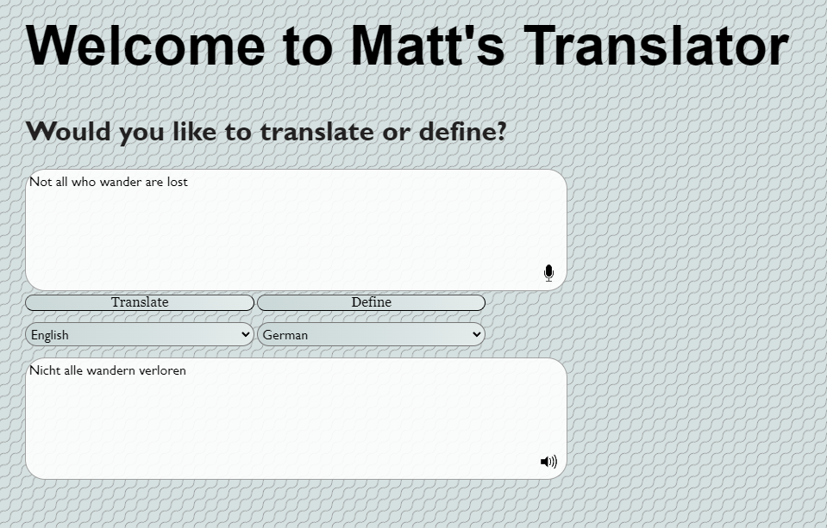

Figure 65, Final GUI for website with German translation example.

There was an immediate issue found with the translations, where the model uses RNN it will predict the next word if an example is not found within any of its training or fine tuning, this meant that there was a recurring word ‘visitars’ which would occur as a translation of the word visit, this may be because the word visit did not appear in any of the datasets presented to the model meaning that the model has taken a prediction of what the outcome could be.

Conclusion

In Conclusion, this project has been very successful. There has been a lot looked into in the world of AI and NLP. During the timescale of this project several working models were created and by the deadline date a working model was working and implemented within a website, the website was made to be more aesthetically pleasing for customers using the CSS language utilised with the HTML language for the backbone of the site. The backend of the website was ran entirely using Python and its Flask module so that the website could be ran on local host. The working AI models were T5 models which were fine-tuned on several databases for their own purposes and were successful in them.

Every step of this project went according to plan for the most, there were very few changes made to the initial plans and the UML charts and Gantt charts which were made towards the start of the project are still relevant to the work completed.

In regard to the requirements of the project, the results yielded have been uplifting, with only one of requirements not met, this heavily implicates the project as a success.

|  |  |  |  |
| --- | --- | --- | --- |
| Requirement | Relevance (MoSCoW) | How? | Was the requirement accomplished? |
| Model translates | Must | Use of a text-to-text transfer transformer model which has been fine tuned | Yes |
| Detect the Language | Should | Python module which allows for 55 languages to be detected | Yes |
| Define words | Could | Python module which gives accurate definitions of words | Yes |
| Utilise microphone on devices | Could | HTML code which reverts back to python for transfer. | Yes |
| Implement into Website | Must | Use of Flask, a python addon. | Yes |
| Make accessible for mobile site | Could | Use of HTML and CSS to make it available for website | No |
| Use CSS to ensure website is attractive for users | Could | The programming language CSS (cascading style sheets) allows for HTML to be customised and made more attractive for users | Yes |

Figure 66, Updated requirements table with included section for if the requirement was accomplished.

The requirements being met shows that the process and project was a success, alongside the lack of issues and the lack of change in plans this project has been entirely worthwhile and a testament towards good planning and use of time, the plan from the start was to work alongside the made timeline on the Gantt chart to ensure a working model and report for the deadline, due to doing this the project and report are complete.

The main goals for this project were to create a working AI model to allow more interconnection between people, with a model allowing for several working languages to translating between one and another this has been successfully done, as well as looking into machine learning techniques and theories behind NLP and certain AI models this project and report have been successfully completed and as a whole have been a positive result.

With the world of AI and NLP ever expanding there has to be thought on how things could be developed further, given more time for future developments on this project, there would be a great attraction to adding in features such as a camera option to scan words and detect them, as well as options for adding in more language’s and reducing the amount of inconsistencies between translations, adding in spell check features so that the model will take into account spelling errors and even implementation of the website into a server so that it is accessible for all members of the public.

References:

Please note that the references are arranged in alphabetical order by the author.

Boden, M. A., et al. (1996). *Artificial Intelligence.* Brighton: School of Cognitive Computer Sciences, University of Sussex.

Bpstudios.com. (2017). *15 Web Design Statistics You Should Know*. [online] Available at: https://bpstudios.com/Blog/March-2017/15-Web-Design-Statistics-You-Should-Know [Accessed 16 Apr. 2024].

Cambridge.org. (2019). *TRANSLATE in English, Spanish, French and more with Cambridge*. [online] Available at: https://dictionary.cambridge.org/translate/.

Cao, X., Liu, X., Zhu, B., Miao, Q., Hu, C. and Xu, F. (n.d.). *Semantic Matching Using Deep Multi-Perception Semantic Matching Model with Stacking*. [online] Available at: https://ceur-ws.org/Vol-2242/paper12.pdf [Accessed 16 Apr. 2024].

Chowdhary, K.R. (2020). *Fundamentals of Artificial Intelligence*. Springer, New Delhi. https://doi.org/10.1007/978-81-322-3972-7_19

Danilak, M.M. (n.d.). *langdetect: Language de tection library ported from Google’s language-detection.* [online] PyPI. Available at: https://pypi.org/project/langdetect [Accessed 16 Apr. 2024].

DeepL (2019). *DeepL Translator*. [online] Deepl.com. Available at: https://www.deepl.com/translator.

Embrey, L. (2021). *15 Gorgeous CSS Text Animation Effects [Examples]*. [online] Alvaro Trigo’s Blog - Web developing and design. Available at: https://alvarotrigo.com/blog/css-text-animations/.

GeeksforGeeks. (2018). *seq2seq model in Machine Learning*. [online] Available at: <https://www.geeksforgeeks.org/seq2seq-model-in-machine-learning/>.

Google (2006). *Google Translate*. [online] Google.com. Available at: https://translate.google.com/.

*How can NLP-based Language Translation solve Real-World Problems?* (2023). Available at: https://www.linkedin.com/pulse/how-can-nlp-based-language-translation- (Accessed: 9 December 2023).

huggingface.co. (n.d.). *Inference*. [online] Available at: https://huggingface.co/docs/huggingface_hub/en/package_reference/inference_client [Accessed 16 Apr. 2024].

huggingface.co. (n.d.). *T5*. [online] Available at: https://huggingface.co/docs/transformers/en/model_doc/t5.

IBM (2023). *What are Recurrent Neural Networks? | IBM*. [online] www.ibm.com. Available at: https://www.ibm.com/topics/recurrent-neural-networks.

Medium. (n.d.). *Medium*. [online] Available at: https://medium.com/analytics-vidhya/t5-a-detailed-explanation-a0ac9bc53e51.

Menzli, A. (2021). *Tokenization in NLP: Types, Challenges, Examples, Tools*. [online] neptune.ai. Available at: <https://neptune.ai/blog/tokenization-in-nlp>.

Natural Language Toolkit. (2023). *Natural Language Toolkit (NLTK) — NLTK 3.6.3 documentation*. NLTK. Available at:<https://www.nltk.org/> (Accessed: January 22,

2024).

Pitman, J. (2021). *Google Translate: One billion installs, one billion stories*. [online] Google. Available at: <https://blog.google/products/translate/one-billion-installs/>.

PyPI. (2016). *langdetect*. [online] Available at: https://pypi.org/project/langdetect/.

Python.org. (2019). *Python Releases for Windows*. [online] Available at: <https://www.python.org/downloads/windows/>.

Raffel, C., Shazeer, N., Roberts, A., Lee, K., Narang, S., Matena, M., Zhou, Y., Li, W. and Liu, P.J. (2019). *Exploring the Limits of Transfer Learning with a Unified Text-to-Text Transformer*. [online] arXiv.org. Available at: <https://arxiv.org/abs/1910.10683>.

research.google. (n.d.). *Google’s Neural Machine Translation System: Bridging the Gap between Human and Machine Translation*. [online] Available at: <https://research.google/pubs/googles-neural-machine-translation-system-bridging-the-gap-between-human-and-machine-translation/>.

Taira, B. R. *et al.* (2021) ‘A Pragmatic Assessment of Google Translate for Emergency Department Instructions’, *Journal of general internal medicine*, 36(11), pp. 3361–3365. doi: 10.1007/S11606-021-06666-Z.

The Thomas B. Fordham Institute. (2015). *Theory without experience is intellectual play*. [online] Available at: https://fordhaminstitute.org/national/commentary/theory-without-experience-intellectual-play#:~:text=To%20be%20clear%2C%20it [Accessed 16 Apr. 2024].

Vetulani, Z., Paroubek, P. and Uniwersytet im. Adama Mickiewicza w Poznaniu (2023) *Human language technologies as a challenge for computer science and linguistics. 2023*. Poznań : Wydawnictwo Naukowe Uniwersytetu im. Adama Mickiewicza w Poznaniu

Wu, Y., Schuster, M., Chen, Z., Le, Q.V., Norouzi, M., Macherey, W., Krikun, M., Cao, Y., Gao, Q., Macherey, K., Klingner, J., Shah, A., Johnson, M., Liu, X., Kaiser, Ł., Gouws, S., Kato, Y., Kudo, T., Kazawa, H. and Stevens, K. (2016). *Google’s Neural Machine Translation System: Bridging the Gap between Human and Machine Translation*. [online] arXiv.org. Available at: <https://arxiv.org/abs/1609.08144>.

Zhou, M. *et al.* (2020) ‘Progress in Neural NLP: Modeling, Learning, and Reasoning’, *Engineering*, 6(3), pp. 275–290. Available at: <https://doi.org/10.1016/J.ENG.2019.12.014>.

Appendix:

Please note there will be no code snippets within this section, hence the inconsistency within figure numbering.

|  |  |  |
| --- | --- | --- |
| Requirement | Relevance (MoSCoW) | How? |
| Model translates | Must | Use of a text-to-text transfer transformer model which has been fine tuned |
| Detect the Language | Should | Python module which allows for 55 languages to be detected |
| Define words | Could | Python module which gives accurate definitions of words |
| Utilise microphone on devices | Could | HTML code which reverts back to python for transfer. |
| Implement into Website | Must | Use of Flask, a python addon. |
| Make accessible for mobile site | Could | Use of HTML and CSS to make it available for website |
| Use CSS to ensure website is attractive for users | Could | The programming language CSS (cascading style sheets) allows for HTML to be customised and made more attractive for users |

Figure 1, Page 5



Figure 2, Page 9



Figure 3, Page 10



Figure 4, Page 11



Figure 6, Page 13



Figure 7, Page 14



Figure 8, Page 15



Figure 9, Page 16



Figure 10, Page 18



Figure 12, Page 18



Figure 13, Page 20



Figure 14, Page 20



Figure 20, Page 23



Figure 21, Page 23



Figure 22, Page 24



Figure 25, Page 27



Figure 26, Page 27



Figure 28, Page 29



Figure 33, Page 33



Figure 34, Page 34



Figure 35, Page 35



Figure 41, Page 37



Figure 43, Page 39



Figure 44, Page 38



Figure 45, Page 39



Figure 46, Page 39



Figure 47, Page 40

Figure 48, Page 41



Figure 55, Page 48



Figure 56, Page 48



Figure 57, Page 49



Figure 58, Page 49



Figure 59, Page 50

|  |  |  |
| --- | --- | --- |
| Flask and HTML testing | | |
| Name of test | Participant / Date | Was the test successful? |
| Flask running on local | Participant 1, 12/02/2024 | Success |
| Implementing HTML code for features | Participant 1, 12/02/2024 | Success |

Figure 60, Page 50

|  |  |  |
| --- | --- | --- |
| T5 Model implementation and usage | | |
| Name of test | Participant / Date | Was the test successful? |
| Implement the T5 model and loading the datasets | Participant 1 / 14/03/2024 | Success |
| Dataset fine tuning on French | Participant 1 / 14/03/2024 | Success |
| Dataset fine tuning on Spanish | Participant 1 / 15/03/2024 | Success |
| Dataset fine tuning on Italian | Participant 1 /16/03/2024 | Fail (dataset too small) |
| Dataset fine tuning on Italian | Participant 1 / 17/03/2024 | Success (Use of different dataset found) |
| Dataset fine tuning on German | Participant 1 / 18/03/2024 | Success |
| Dataset fine tuning on Romanian | Participant 1 / 18/03/2024 | Success (was included in the German dataset) |
| Dataset fine tuning on Portuguese | Participant 1 / 18/03/2024 | Fail (Dataset too small, no ideal dataset to be found) |
| Usability of the inference program | Participant 1 / 19/03/2024 | Success (implemented print codes to check each step) |

Figure 61, Page 51

|  |  |  |
| --- | --- | --- |
| Implementation of the Features | | |
| Name of test | Participant / Date | Was the test successful? |
| Adding define feature to define button | Participant 1 / 22/03/2024 | Success |
| Adding in the translation models for the translate button | Participant 1 / 22/03/2024 | Success (However took longer than originally expected) |
| Applying the different models based on the language dropdown | Participant 1 / 22/03/2024 | Success |
| Adding in a detect language feature | Participant 1 / 22/03/2024 | Success |
| Voice input and text to speech output | Participant 1 / 23/03/2024 | Success |

Figure 62, Page 52

|  |  |  |
| --- | --- | --- |
| CSS | | |
| Name of test | Participant / Date | Was the test successful? |
| Connecting the HTML and CSS sheets together | Participant 1 / 24/03/2024 | Failure |
| Connecting the HTML and CSS sheets together Test 2 | Participant 1 / 24/03/2024 | Failure |
| Connecting the HTML and CSS sheets together Test 3 | Participant 1 / 24/03/2024 | Failure |
| Connecting the HTML and CSS sheets together | Participant 1 / 24/03/2024 | Success |
| Adding background into the CSS | Participant 1 25/03/2024 | Success |
| Adding animation into the CSS | Participant 1 /26/03/2024 | Success |

Figure 63, Page 52

|  |  |  |  |  |
| --- | --- | --- | --- | --- |
| Final Product Testing | | | | |
| Name of Test | Participant / Date | Was the test Successful (Translate) | Was the test Successful (Define) | Overall thoughts |
| Test 1 (French language) | Participant 2  06/04/2024 | 5/5 Translations | 3/3 Definitions | “The squiggly background is hard on the eyes, but the animation looks good”.  “French works very well”  “Could change it so source language is based off the detected one” |
| Test 2 (Spanish language) | Participant 3  08/04/2024 | 3/5 Translations | 3/3 Definitions | “The wording isn’t quite right on Spanish”.  “The website looks cool” |
| Test 3 (Italian language) | Participant 4 09/04/2024 | 3/5 Translations | 2/3 Definitions | “Context is not quite right but technically correct”.  “Website looks nice.” |
| Test 4 (German language) | Participant 5 09/04/2024 | 5/5 Translations | 3/3 Definitions | “The translations are correct but strangely phrased, logically they make sense but not how it would be spoken in tongue” |
| Test 5 (Romanian language) | Participant 6 10/04/2024 | 4/5 Translations | 2/3 Definitions | “Accurate”  “I like the define addition” |

Page 64, Page 54



Figure 65, Page 56

|  |  |  |  |
| --- | --- | --- | --- |
| Requirement | Relevance (MoSCoW) | How? | Was the requirement accomplished? |
| Model translates | Must | Use of a text-to-text transfer transformer model which has been fine tuned | Yes |
| Detect the Language | Should | Python module which allows for 55 languages to be detected | Yes |
| Define words | Could | Python module which gives accurate definitions of words | Yes |
| Utilise microphone on devices | Could | HTML code which reverts back to python for transfer. | Yes |
| Implement into Website | Must | Use of Flask, a python addon. | Yes |
| Make accessible for mobile site | Could | Use of HTML and CSS to make it available for website | No |
| Use CSS to ensure website is attractive for users | Could | The programming language CSS (cascading style sheets) allows for HTML to be customised and made more attractive for users | Yes |

Figure 66, Page 56